**Daily Scrum or Standup Meeting**

Team name: ________Group 2_________________

Scrum Master: ______Emily_________________

Date:________10/12_______________________

| **Team Member** | **What did you do since the last scrum?** | **What do you plan to do before the next scrum?** | **What obstacles do you have?** |
| --- | --- | --- | --- |
| Emily | Researched CRUD options for Django | Create a partial for the page headers | Fall Break |
| Karl | Fixed overflow, styled login and register pages | Peer review | Tying it all together, consistent styling |
| Andre Nguyen | Fixed the add drink method and started to replace the functionality of the remove drink | Wrap up the add drink and remove drink method and peer review one of Emily’s task (peer review) | Full time career outside of Logan |
| Maris | Successfully connected all login and logout logic to the html views and added different user types | finish database migration script | Need more time |
|  |  |  |  |

# Burndown

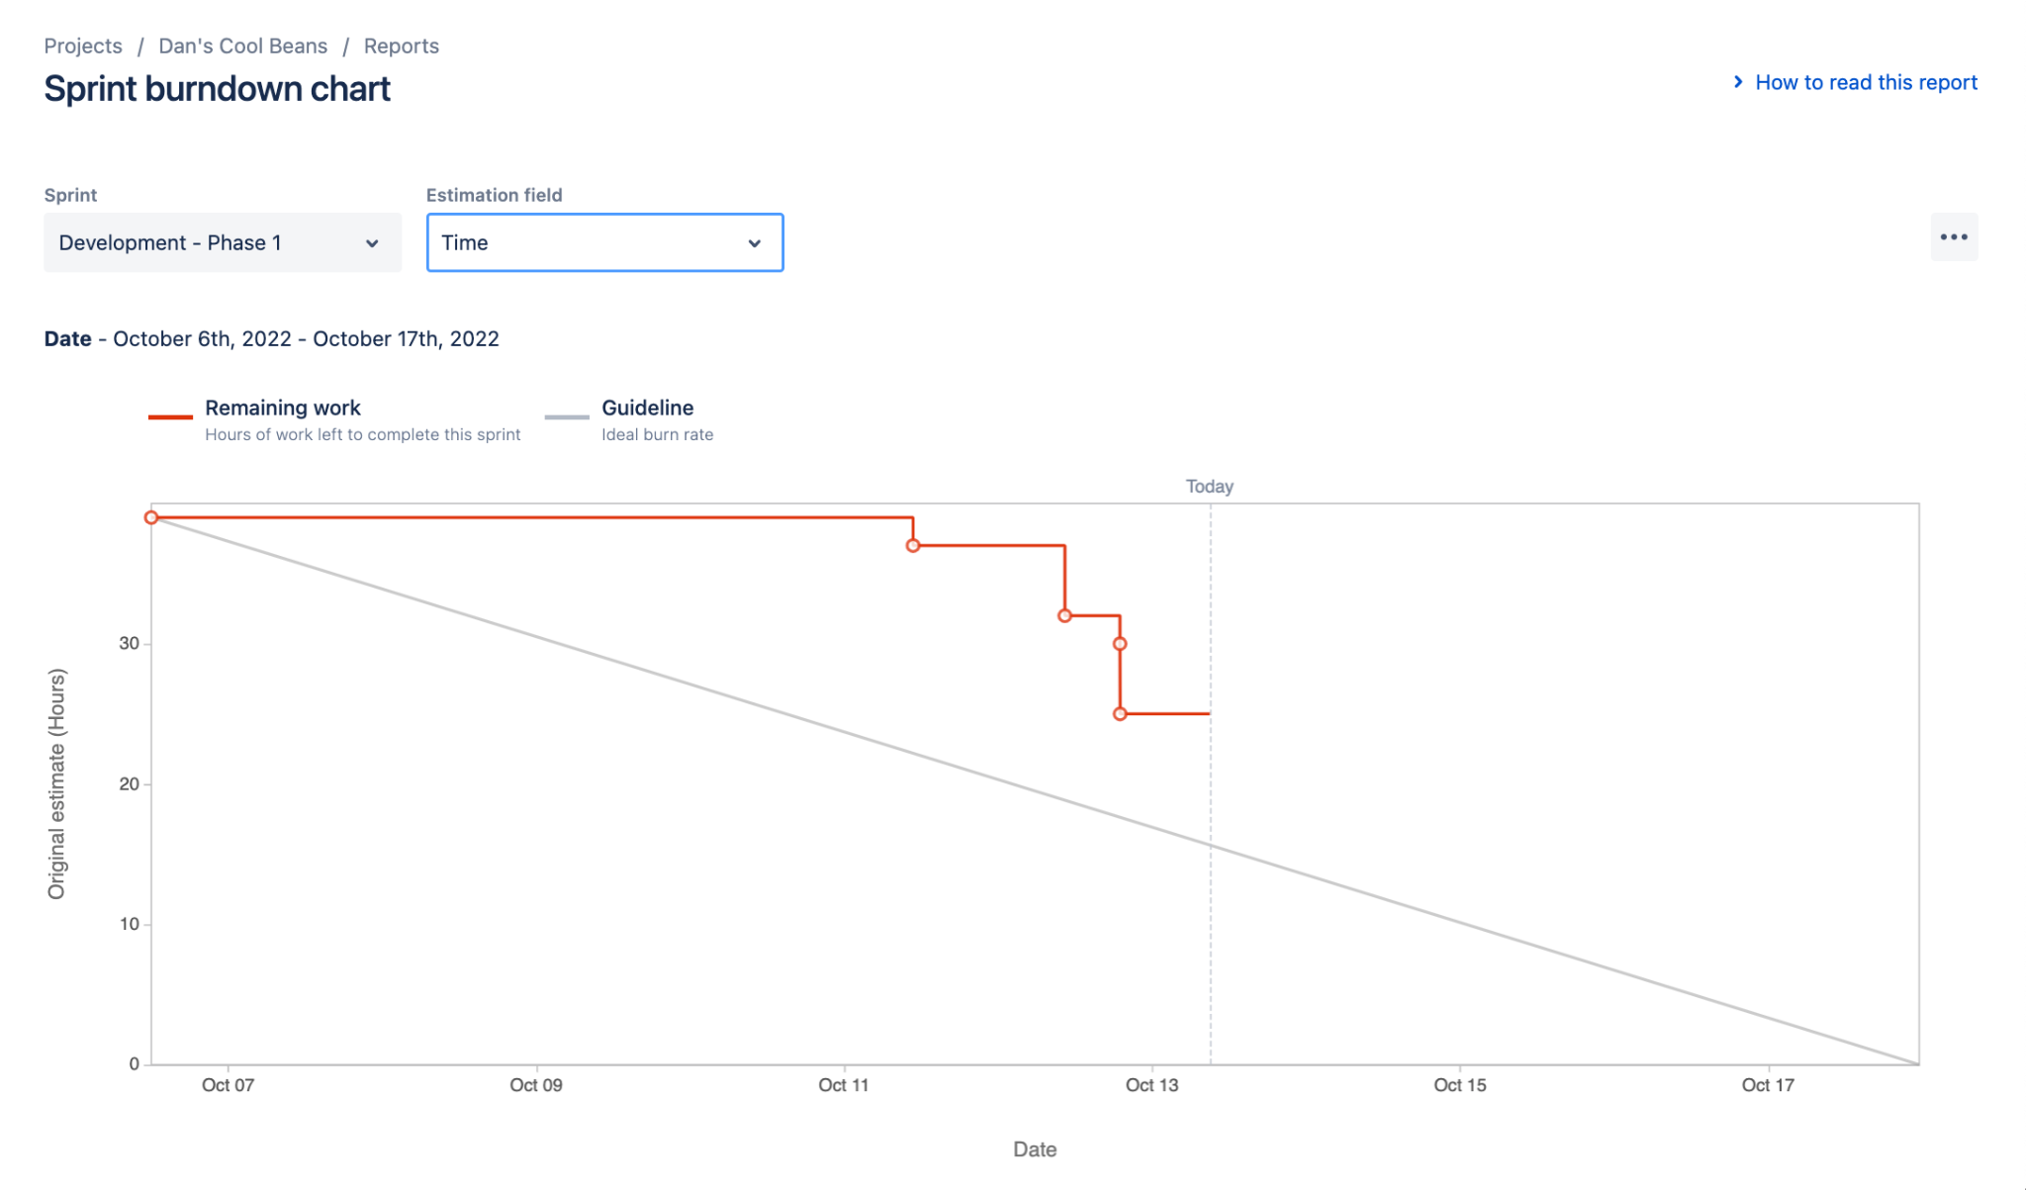

# Screenshot of you project board

